Big Ice-E Dairy Showdown
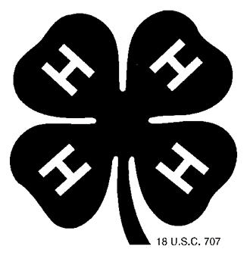
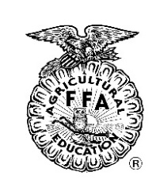
22nd Annual Elbert County Dairy Heifer Show
January 28, 2023
Sponsored by Hart EMC
Athens Tech McCall Arena
1317 Athens Hwy, Elberton, GA 30635
FFA Advisors and 4-H Leaders,
Please join us for the rebranded “Big Ice-E Dairy Showdown” 22nd Annual Elbert County Dairy Heifer show to be held on January 28, 2023 at the McCall Livestock Arena and Center in Elberton, Georgia. This show will be open to all FFA or 4-H members in Georgia.
The entry fee is $15 per heifer. There is no maximum number for heifers that can be registered, however, there can only be one exhibitor per heifer (i.e. two exhibitors cannot show the same heifer). Classes will be divided into heats depending on the number of entries per class or division. All state show rules will apply and health papers will be required. If we have any exhibitors that wish to show register, we will have separate weight classes for registered heifers.
It is recommended that you bring a generator as plug-ins outside of the stalling area will be limited. The Elbert County FFA Alumni will be running a concession stand and will be pre-ordering Chick-fil-a sandwiches to have for lunch at our show. If you are interested in ordering a sandwich or sack bag (sandwich, chips, dessert, & drink), please fill out the following form or contact me by email/phone to pre-order yours. We will only have a few sandwiches leftover for sale, so please pre-order! We will also have a concession stand available with drinks, chips, desserts, snacks, coffee, and hot chocolate.
https://forms.gle/z8u7r3JeyKsaasaRA
We will also be selling short sleeve ($15) and long sleeve ($20) t-shirts this year. https://forms.gle/vxHXpMB8cjQmQihB9
Please return entry forms and fees by January 23rd to:
ECCHS FFA
600 Abernathy Circle
Elberton, GA 30635
Make Checks Payable to: Elbert County FFA Alumni
If you have further questions or concerns, contact Mrs. Jordan Paul at 706-621-9351 or jordan.paul@elbert.k12.ga.us
See you at the show,
Jordan Paul
Elbert County High FFA Advisor

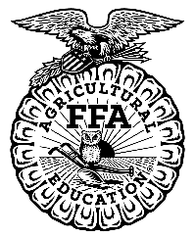

Big Ice-E Dairy Showdown
22nd Annual Elbert County Dairy Heifer Show
January 28, 2023
Sponsored by Hart EMC
Athens Tech – McCall Arena
1317 Athens Hwy, Elberton, GA 30635

Friday, January 27th, 2023
If you will require stalling Friday night – please contact Jordan Paul at 706-621-9351 to make arrangements.
Saturday, January 28th
6:30 AM – Barn Opens
8:00-10:00 AM – Weigh In
10:30 AM Showmanship Starts, Weight Classes will follow

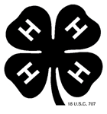
22nd Annual Elbert County Dairy Heifer Show
January 28, 2023
Sponsored by Hart EMC
1317 Athens Hwy, Elberton, GA 30635
Entries and Entry Fees due January 23rd
^{$15 per Heifer}
COUNTY or CHAPTER:______________________________________ ORGANIZATION: 4-H / FFA
Advisor/Agent:____________________________________________ Phone:____________________
Address:______________________________________________________________________________
Email:_____________________________________________________
EXHIBITOR NAME | GRADE | HEIFER TAG #
TOTAL # OF DIFFERENT EXHIBITORS ENTERED: _______________ TOTAL AMOUNT DUE:________
SIGNATURE OF PARENT/GUARDIAN OR AGENT/ADVISOR:
__________________________________________ Print: ______________________

